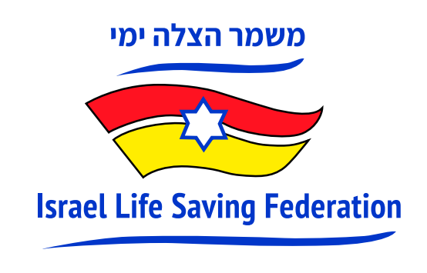
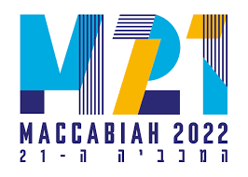

Competitive Lifesaving: A New and Old Sport,
Makes Debut at Maccabiah Games 2022

(JULY 19, TEL AVIV) Surf lifesaving competitions will be held for the first time as an exhibition sport as part of the Maccabiah Games on July 20th and 21st at Poleg Beach, Netanya, at the Maccabiah Village.
An initiative of the Israel Life Saving Federation (ILSF), Maccabi World Union has introduced Competitive Lifesaving Sports as a new exhibition sport in the 2022 Maccabiah. The events are hosted by the ILSF, a nonprofit volunteer-based organization and member of the International Life Saving Federation (comprising 148 national federations), that seeks to prevent drownings through education and practical courses for all age groups.

What is Competitive Surf Lifesaving?
Surf lifesaving is a multi-faceted sport and social movement that combines surf awareness, swimming, lifesaving techniques and general fitness, based on the iconic Australian model for surf life saving and water safety. Lifesaving sports activities consist of elements of rescue, such as speed of reaction, running, swimming or board paddling towards a person at sea and back with them in the shortest time. The competitions consist of performing various tasks in teams and as individuals such as those performed by lifeguards at the beach (runners, paddlers, swimmers.)

Power of Sport
Extremely popular in Australia and New Zealand, surf lifesaving carnivals on the beach have a strong presence in Canada, the US and Europe. Eighty years after the ANZAC lifesavers competed in a surf lifesaving carnival on Israel’s Jaffa beach, this event is set to boost the iconic Australian sport on a global stage as part of the 2022 Maccabiah Games. The sport is also vying for a place at the 2028 L.A. Olympics and 2032 Brisbane Olympics.

Competitive Lifesaving at the 2022 Maccabiah
Participating in the inaugural demonstration event at the Maccabiah at Poleg Beach this week will be participants from around the world including from Israel, Morocco, Australia, France, Singapore, South Africa, and Poland. In addition, the event will be judged by judges of the International Life Saving Federation from Morocco, Germany and England.

Paul Hakim, a native of Australia, is CEO and co-founder of ILSF. Hakim took his passion for the beach and Australian surf life saving culture and brought the iconic Nippers program to Israel, together with his brother, Danny Hakim OAM. The ILSF runs year-round water safety and surf rescue programs for children and adults, provides water safety volunteer teams to staff national swimming events, and lobbies Israel’s national and local governments to prevent drownings along the country’s coasts.

Hakim says, “Every drowning is tragic and yet most are preventable. Graduates of the ILSF programs are trained on water safety and to be first responders should they happen to be present when someone is drowning, thus helping mitigate a deadly scourge of the Israeli summer. We are delighted that the Maccabiah recognizes surf lifesaving as an important sport to demonstrate on an international platform.” To date, ILSF course graduates since 2019 have performed more than 70 rescues.

Roy Hessing, Maccabiah’s Chief Executive Officer says, “On behalf of the Maccabiah, we extend a warm welcome to competitive lifesaving sports this year. As a lover of water and water sports myself, the introduction of surf lifesaving in Israel, which is not a new movement in other parts of the world, is a step in the right direction to establish a nation-wide water safety awareness and rescue culture.”

Matthew Wise, Deputy Head of Mission, Embassy of Australia in Israel, explains the significance and success of the iconic institution of Surf Life Saving. “Over 800,000 lives have been saved by Australian Lifesavers since its establishment in 1907 and the movement maintains a community of 180,000 volunteers, representing the largest volunteer movement of its kind in the world. It’s great to see this iconic Australian cultural export taking off in Israel. Bringing people from multiple cultures together on the beach with a single goal — to save lives — is a mission worthy of praise and support.”

Drownings in Israel
Drownings in Israel have been a growing serious issue in the past decade. Every summer, hundreds of Israelis drown or require medical attention after nearly drowning. The sport’s historic debut at the Maccabiah comes a week after a series of chaotic days on Israel’s beaches and waterways, as medics rushed to a seemingly endless string of drownings and near-drownings that left many in critical or serious condition, including several children. A total of 20 people have died in Israel from drowning since the start of the beach season on April 16. During the 2021 swimming season, there were 40 drowning deaths in Israel, and another 208 near-drownings that needed medical assistance.
Israel’s coastline spans 350km, of which, only 17km of beaches offer rescue services. Since 2010 a mere 21 declared beaches have been added, totalling 157 declared beaches despite the growing population, which is almost at 10 million citizens. In Israel, drowning is the number one cause of death of children in the summer. Most drownings occur on unpatrolled beaches, and 60% of cases occur when lifeguards are off duty.

Last year, as the world commemorated the UN-designated International Drowning Prevention Day on July 25th, 7 Israelis drowned, marking it the deadliest day of drowning last year. This year, the occasion will be marked with a reception hosted at the Residence of the Australian Ambassador to Israel.

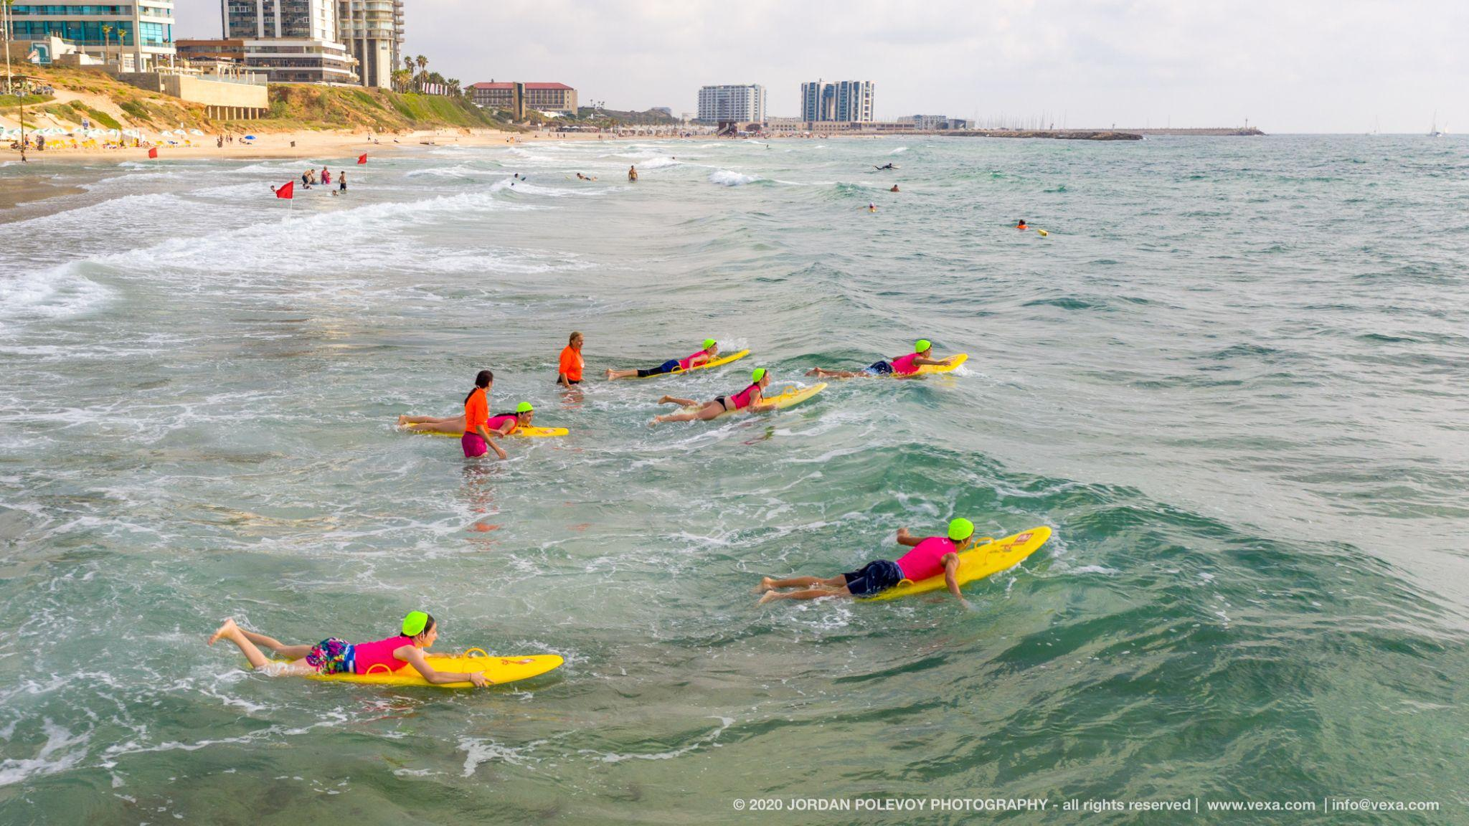
Pictured: Lifesavers in training with ILSF on the beach in Israel. Credit: Jordan Polevoy

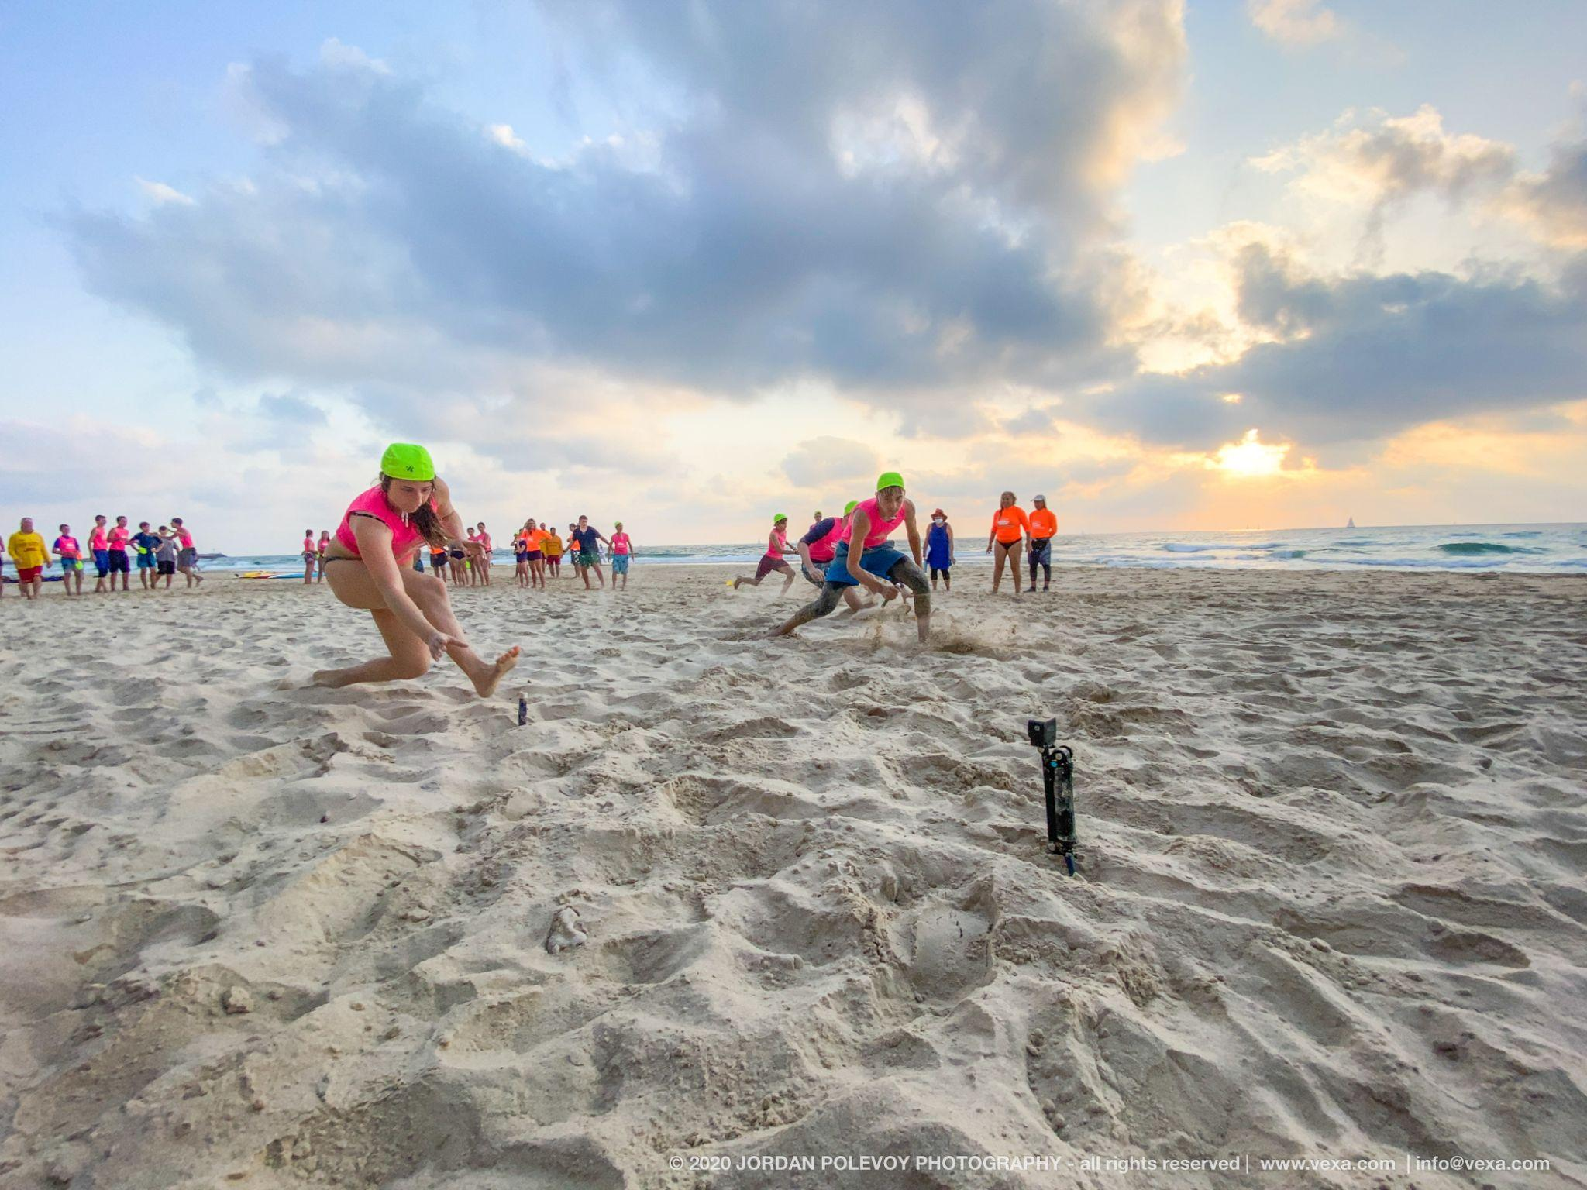
Pictured: Lifesavers in training with ILSF on the beach in Israel. Credit: Jordan Polevoy

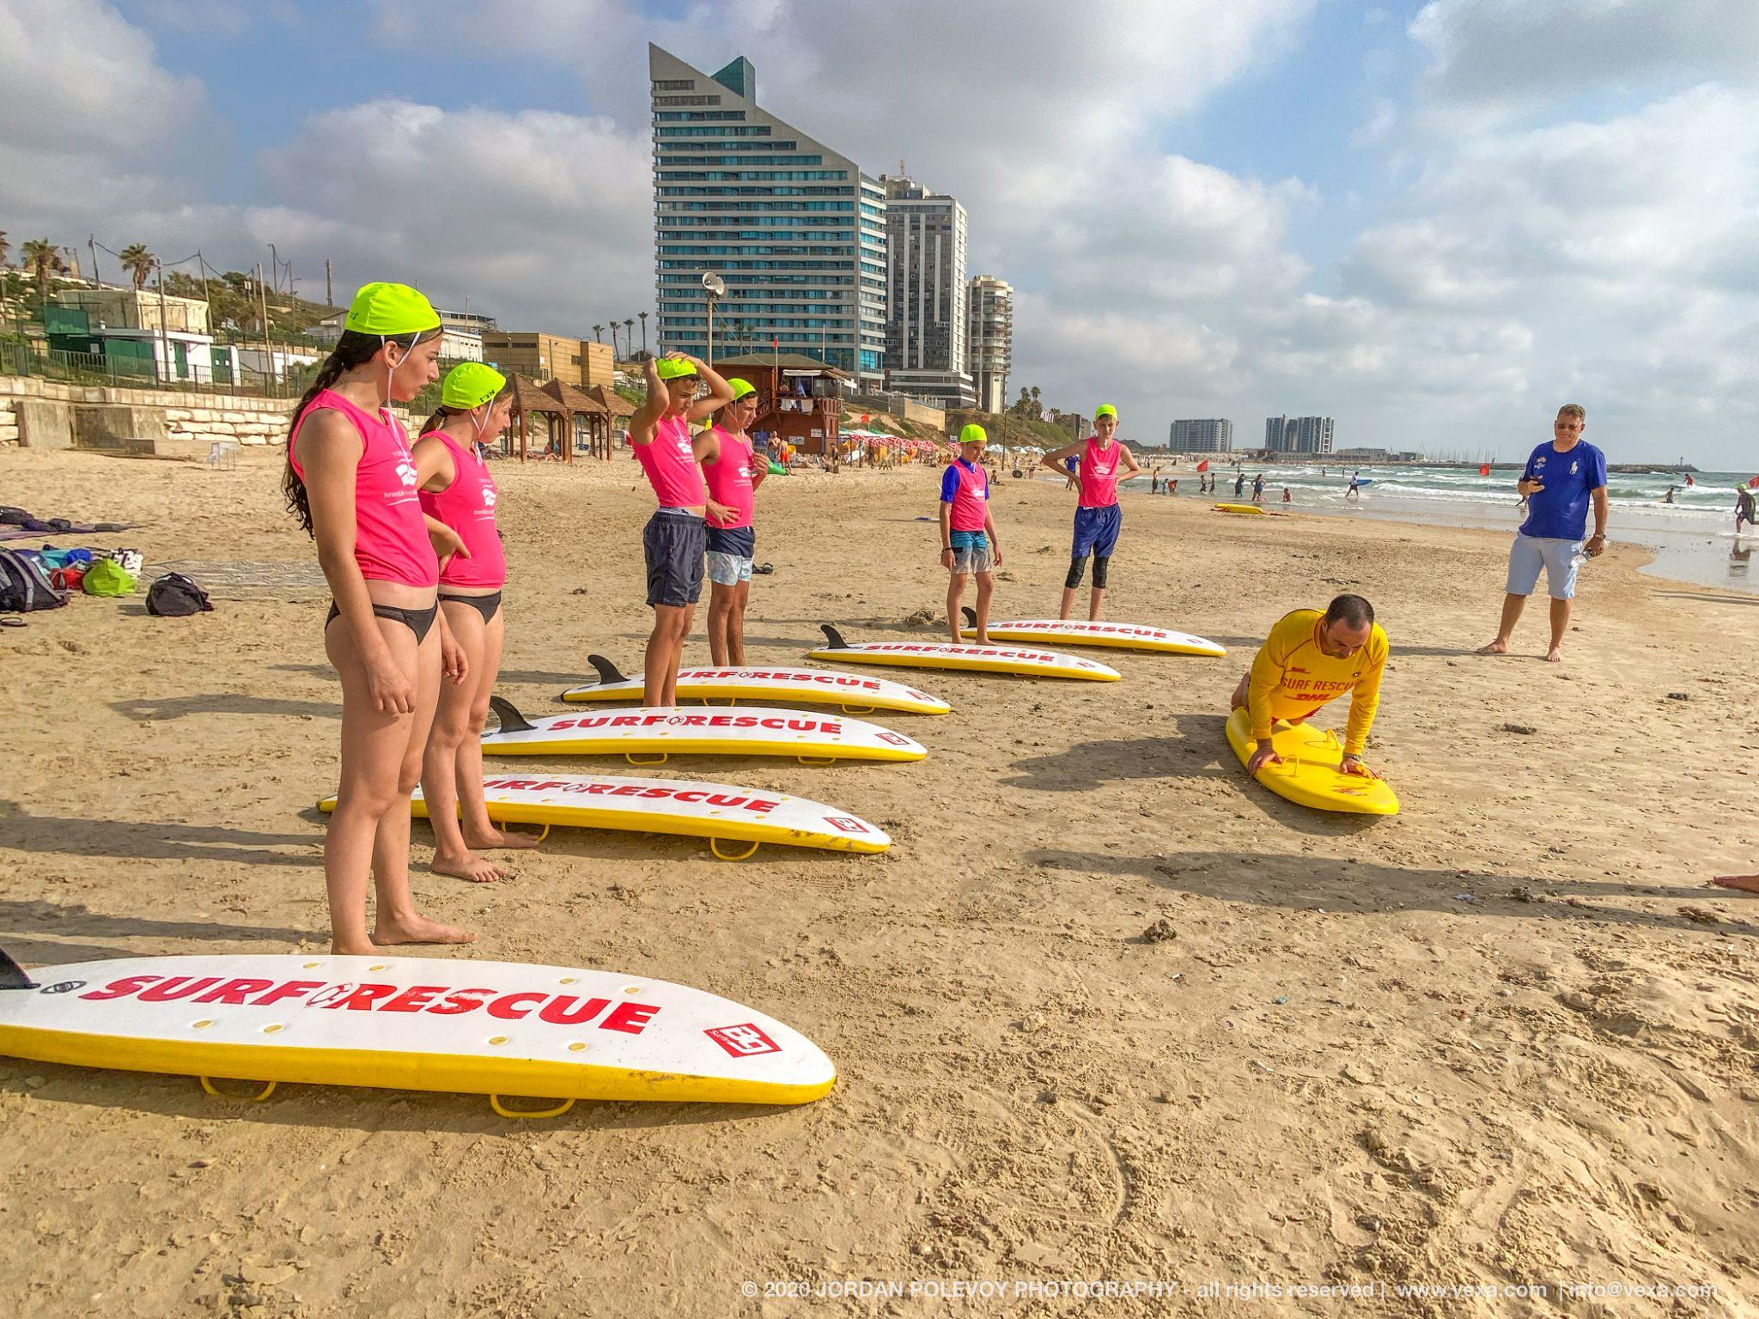
Pictured: Nippers train with ILSF on the beach in Israel. Credit: Jordan Polevoy

The A.I.F. [Australian Imperial Force] Surf Carnival display at Tel-Aviv
1941 October 10. | 1 negative | Matson Photo Service
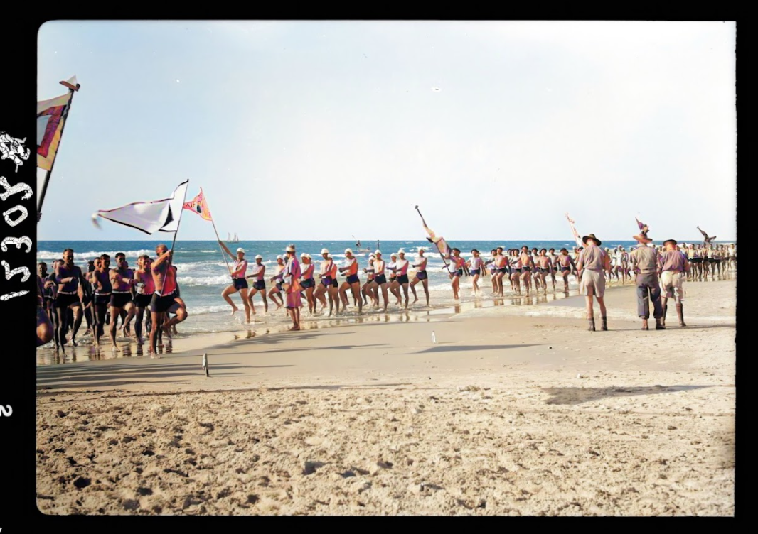
Image restored and colourised by MyHeritage.com

The A.I.F. [Australian Imperial Force] Surf Carnival display at Tel-Aviv
1941 October 10. | 1 negative | Matson Photo Service
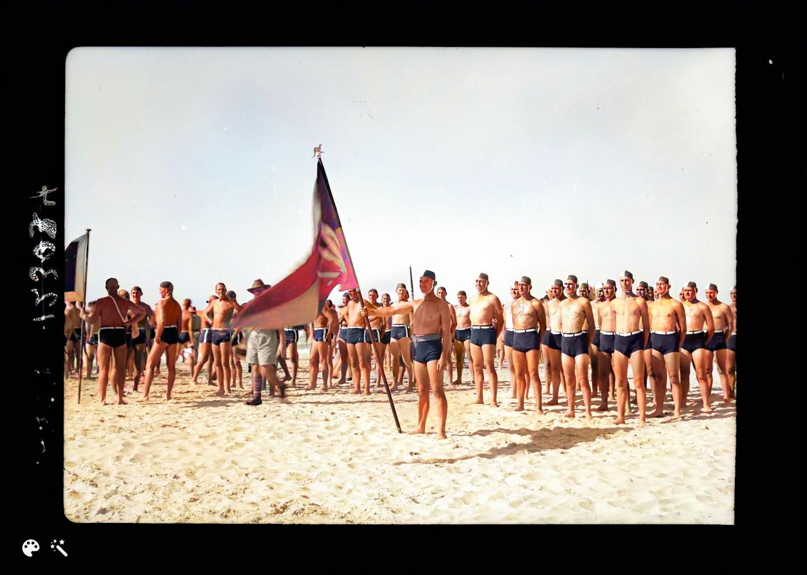
Image restored and colourised by MyHeritage.com

The A.I.F. [Australian Imperial Force] Surf Carnival display at Tel-Aviv
1941 October 10. | 1 negative | Matson Photo Service

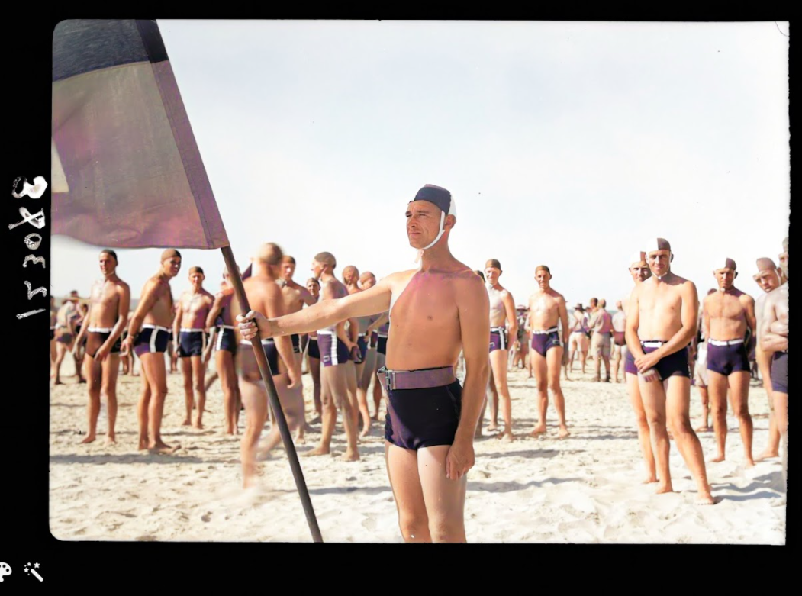
Image restored and colourised by MyHeritage.com

###
About ILSF
Israel Life Saving Federation (ILSF) is an Israeli registered non-profit, community-based volunteer organization whose goal is to prevent drownings across Israel through education and practical courses, and to promote competition lifesaving as a sport in Israel and the region. Founded in 2019, the ILSF is Israel’s local member of the International Life Saving Federation (comprised of 148 national federations), the European Life Saving Federation and the Australian Surf Life Saving Association. To date, ILSF course graduates since 2019 have performed more than 70 rescues.
For Media Inquiries (photos, materials, interviews)
Sarah Vanunu, ILSF
+972-54-547-4306 sarahvanunu@gmail.com

Paul Hakim, CEO, ILSF
052-857-7666 paul@israellifesaving.org

Ravit Ben-Amitai, Chairwoman, ILSF
054-980-6767 Ravit.BenAmitai@gmail.com

General information about the Israel Life Saving Federation can be found at www.israellifesaving.org

