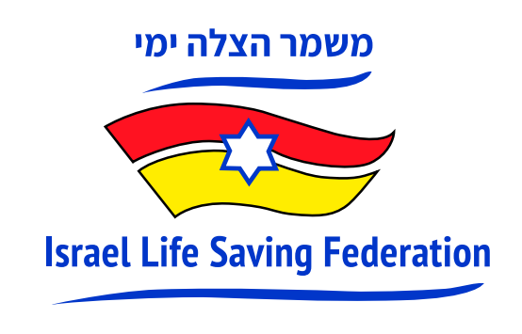

A first: Israel to send team of 2 to compete in Lifesaving World Championships

After being postponed by two years due to COVID-19 disruptions, the Lifesaving World Championships will be held in the coastal town of Riccione, Italy, from 21st September to 3rd October 2022.

(Tel Aviv, Israel) The ILS Lifesaving World Championships are the world championships for lifesaving sport events, conducted every 2 years and attended by qualified members of the International Life Saving Federation (ILS) from various countries around the world. For the first time, Israel is sending two (Australian-born) Israeli representatives to participate in the competition this month.

Competitive lifesaving is a sport that involves "a variety of competitions to further develop and demonstrate lifesaving skills, fitness and motivation," according to the ILS. Competitors at the Lifesaving World Championships will have their skills tested in events that simulate emergency swimming rescue scenarios. The sporting activity consists of elements of rescue, such as reaction speed, running, swimming or paddling on a lifeboard in the sea in the fastest possible time.

National Team Manager, CEO and Co-Founder of Israel Lifesaving Federation (ILSF), Paul Hakim, of Raanana, said “I’m very proud to be leading Israel’s cohort for the first time in the Lifesaving World Championships. I’m excited to be part of this historic event, to put Israel on the world map. There is great potential here in Israel with a lot of enthusiasm that surf lifesaving sport will become a national sport - just like Down Under.”

In July, surf lifesaving competitions were held for the first time in Israel as part of the 21st Maccabiah Games, in which competitors from Israel and other countries in the world took part, including Morocco, Australia, France, Singapore, South Africa and Poland.

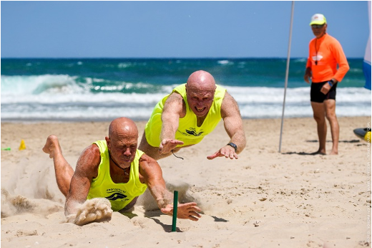
Pictured: CEO of Israel Lifesaving Federation, Paul Hakim (right) together with Yossi Berger (left), owner of WAVES, a surfing club in Ashdod, at the "Flags" competition in the Maccabiah Games in Israel, July 2022. Paul won the bronze medal and competed against the Australian national champion in the competition. Photo credit: Jordan Polevoy

Sarah Vanunu, another Israeli competitor and former Sydney-sider who also competed in the 21st Maccabiah Games, said, “I’m honoured to put on the blue and white cap and represent Israel in such a significant sport close to my heritage as an Australian.”

The Lifesaving World Championships, under the auspices of the International Lifesaving Federation (comprising 148 national federations), typically attract between 3,000 and 5,000 competitors and officials, and are conducted over a period of two weeks. The State of Israel has recently been accepted as a new member of the International Federation.

Neil Ben-Dror, CEO of the Ben-Dror Group which represents Speedo in Israel, a partner of the Israel Life Saving Federation said, “We are thrilled to be able to support Team Israel on their pioneering journey to Riccione and wish them all the best.”

Although Hakim and Vanunu, the Israeli representatives, will have to contend with strong competitors worldwide in this gala of lifesaving – the most significant life-saving competition in the world – this is certainly a significant breakthrough for Israeli sports, which is registering an achievement in a new sport.

Competitive lifesaving will be included as an Olympic sport at the 2028 Los Angeles Olympics and the 2032 Olympics in Brisbane, Australia. Participation in the current World Championships is a first win for Israel and only the sky's the limit.

Paul Hakim  Age: 61  Marital status: Married +2  Place of birth: Sydney, Australia  Residence: Raanana  Occupation: CEO and co-founder, Israel Lifesaving Federation (ILSF) | 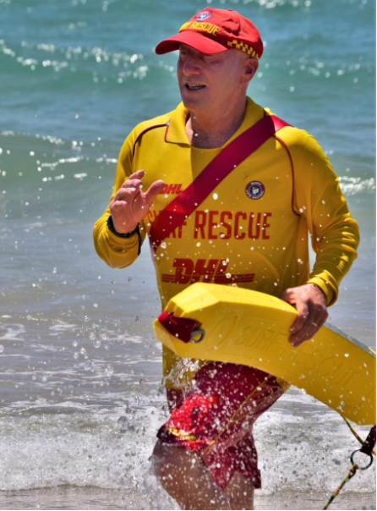

Sarah Vanunu  Age: 40  Marital status: Married + 3  Place of birth : Sydney, Australia  Residence: Tel Aviv  Occupation: Director of Global Public Relations, MyHeritage | 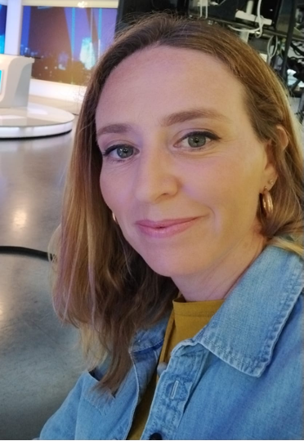

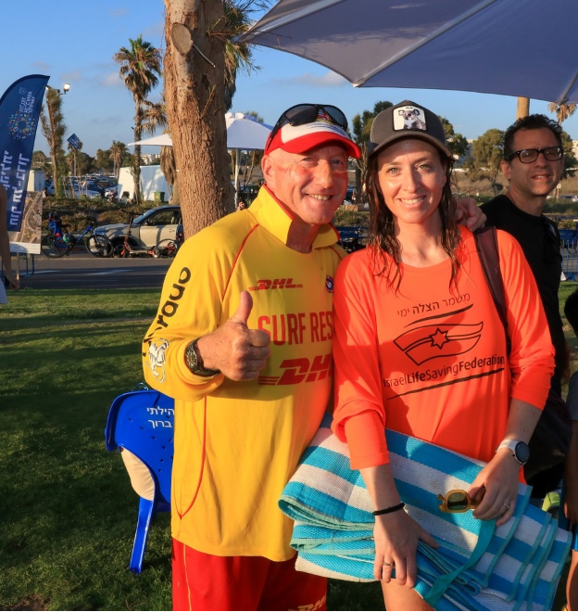
In the photo: (Right) Sarah Vanunu and (left) Paul Hakim.

Photo credits: ILSF

###
About ILSF
Israel Life Saving Federation (ILSF) is an Israeli registered non-profit, community-based volunteer organization whose goal is to prevent drownings across Israel through education and practical courses, and to promote competition lifesaving as a sport in Israel and the region. Founded in 2019, the ILSF is Israel’s local member of the International Life Saving Federation (comprised of 148 national federations), the European Life Saving Federation and the Australian Surf Life Saving Association. To date, ILSF course graduates since 2019 have performed more than 70 rescues.
For Media Inquiries (photos, materials, interviews)
Sarah Vanunu
+972-54-547-4306 sarahvanunu@gmail.com

Paul Hakim, CEO, ILSF
052-857-7666 paul@israellifesaving.org

General information about the Israel Life Saving Federation can be found at www.israellifesaving.org

